I see Him, but not now;
I behold Him, but not nigh:
a star shall come forth out of Jacob,
and a scepter shall rise out of Israel.

Numbers 24:17

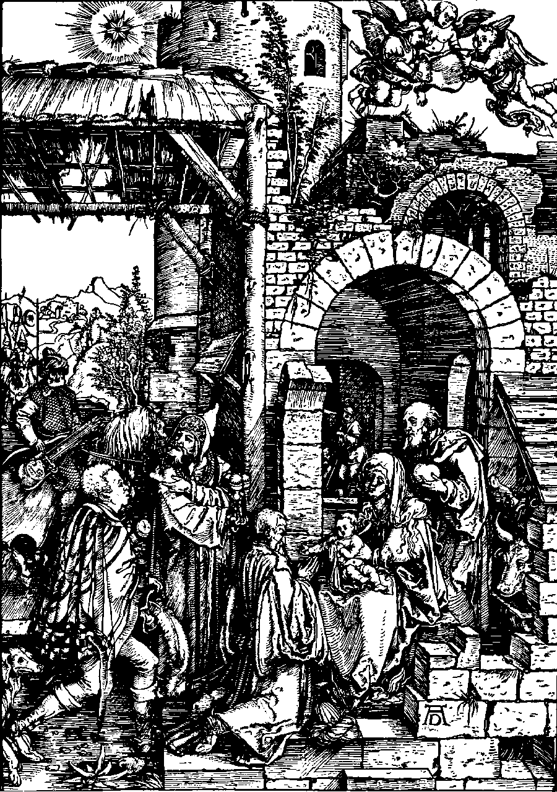
He is born for us, and He is given for us; His birth redounds to our good, since the prophet understands by the little word “us” all men, Jews and Gentiles. For he states in the previous words: This light shines over the people who are wandering in darkness, and he additionally states, God increases the Gentiles. When Scripture contrasts peoples and Gentiles, by “peoples” it indicates the Jews, who were God’s own people, for whom, through the birth of Christ, this light has now arisen. However, not only for them; rather, the joy over this birth will be proclaimed also to the gentiles, just as Simeon nicely makes the change in Lk. 2:32, where he calls the Child a Light for enlightening the Gentiles; as if he wanted to say: this Light has arisen not only for the Jewish people, but also for the Gentiles.

Seven Christmas Sermons
by Johann Gerhard
page 61
© 1995, 1996 by Elmer Hohle, Published by Repristination Press in 1996.
Used with permission.
Click on this word. A box should appear. This box is for the particulars of the congregation, time, address, pastor, etc.
The Epiphany of Our Lord

6 January Anno Domini 2002
Adoration of the Kings is a 1502 woodcut by Albrecht Dürer.
[Notice the evangelical invitation being extended to the Mohammedan.]
Courtesy of Concordia Historical Institute, St. Louis, Missouri.

Scripture text is based on Revised Standard Version © 1946, 1952, 1971 Division of Education and Ministry of the National Council of the Churches of Christ in the United States of America.
All Rights Reserved.

This bulletin cover made available by www.scholia.net and is provided without cost.

Arise, shine; for your Light has come, and the Glory of the Lord has risen upon you (Isaiah 60:1).
I see Him, but not now; I behold Him, but not nigh:
a star shall come forth out of Jacob,
and a scepter shall rise out of Israel.

Numbers 24:17
He is born for us, and He is given for us; His birth redounds to our good, since the prophet understands by the little word “us” all men, Jews and Gentiles. For he states in the previous words: This light shines over the people who are wandering in darkness, and he additionally states, God increases the Gentiles. When Scripture contrasts peoples and Gentiles, by “peoples” it indicates the Jews, who were God’s own people, for whom, through the birth of Christ, this light has now arisen. However, not only for them; rather, the joy over this birth will be proclaimed also to the gentiles, just as Simeon nicely makes the change in Lk. 2:32, where he calls the Child a Light for enlightening the Gentiles; as if he wanted to say: this Light has arisen not only for the Jewish people, but also for the Gentiles.

Seven Christmas Sermons
by Johann Gerhard
page 61
© 1995, 1996 by Elmer Hohle
Published by Repristination Press in 1996.
Used with permission.

To place the graphic on this page:
Click on the graphic on the previous page and copy it.
Come down to this page. Click on the open space above and a graphic box should appear. Paste the graphic.

Change this frame and the box above by clicking the body of the text, deleting this text (not the box) and adding your particulars.
The Epiphany of Our Lord

6 January Anno Domini 2002

Adoration of the Kings is a 1502 woodcut by Albrecht Dürer.
[Notice the evangelical invitation being extended to the Mohammedan.]
Courtesy of Concordia Historical Institute, St. Louis, Missouri.

Scripture text is based on Revised Standard Version © 1946, 1952, 1971 Division of Education and Ministry of the National Council of the Churches of Christ in the United States of America.
All Rights Reserved.

This bulletin cover made available by www.scholia.net and is provided without cost.

Arise, shine; for your Light has come and

the Glory of the Lord has risen upon you (Isaiah 60:1).

